Official league roster - Soccer
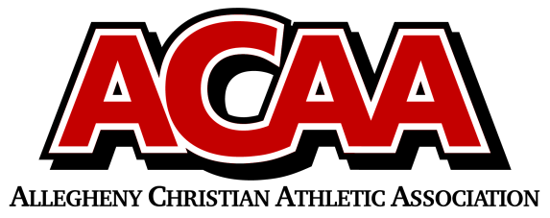

School Name: Johnstown Christian
Team Colors: Royal Blue & White
Overall Wins ___ Losses ____ Ties ___
ACAA Wins ___ Losses ____ Ties ___ OPPONENT: __________________________
Date: _________
Number | Name | Year | Position | Homeschool
10 | Jaydon Yoder | 11 | M | no
20 | Daniel Harper | 10 | D | no
7 | Brayden Kibbe | 10 | M/F | no
15 | Matthew Blough | 10 | Goalie/M | no
9 | Dorin Cook | 10 | D | no
16 | Jeremiah Taylor | 10 | D | no
13 | Nathan Marsh | 10 | D | no
2 | Levi DiGuardi | 9 | M/F | no
11 | Keyahno Richardson-Toney | 9 | F/M | no
1 | Adam Habecker | 9 | M | no
14 | Issak Stanley | 9 | D/Goalie | no
23 | Elijah Swart | 9 | D | no
4 | Shea Tyrrell | 8 | M | no
12 | Malaci Dean | 8 | M/F | no
8 | Carter Rudnik | 8 | M | no
6 | Dominick Bellich | 7 | F | no
5 | Cameron Ledwich | 7 | D/M/F | no
3 | Anthony Burkey | 7 | D/M | no

Head Coach: Brian Grove
Asst. coach: Jeff Grove
Asst. coach: David Sprankle

Official ACAA League Team Roster. to be submitted to the scorer’s table before each game.

